[Year]

ST10377205
HCIN6222 PART 2
KAMOHELO SIMATA
0page

Contents
1. Introduction 2
1.1Functionality the Website Will Offer 3
2.3 Design Principles 7
2.4 Interaction Types 9
2.5 Social Interactions 10
2.6 Emotional Interaction 11
2.7 Accessibility and Guidelines (WCAG 2.1) 12
4. Conclusion 13
References 14

1. Introduction
When I began designing the Academic Time Manager (StudyPro) website, my main goal was to solve one of the biggest personal and academic challenges I face managing time effectively. Like many students, I constantly juggle multiple responsibilities: assignments, tests, part-time work, and social activities. These overlapping commitments often cause procrastination, late submissions, and unnecessary stress, all of which negatively affect academic performance and motivation(W3C 2021)..
I observed that existing tools such as traditional planners, notebook systems, and calendar apps were either too formal or not tailored to the realities of student life. They help with scheduling, but they don’t inspire consistency or emotional engagement. This gap inspired me to design StudyPro a digital productivity assistant created specifically for students(W3C 2021).
StudyPro is built around the idea of combining structure, motivation, and simplicity in one space. It empowers learners to plan their study routines, monitor progress visually, and stay motivated through positive reinforcement. The platform integrates features such as smart scheduling, task management, reminders, motivational messages, and achievement badges all focused on reducing procrastination and promoting steady productivity.
What makes StudyPro different is its student-centered design philosophy. The interface isn’t just functional; it’s emotionally supportive. The site motivates users through encouraging feedback, calming color themes, and a clear, minimal layout that promotes focus. Collaboration and accountability are also key aspects future versions will allow students to share tasks, join study groups, and celebrate collective achievements.
By following Human Computer Interaction (HCI) principles of usability, accessibility, and emotional engagement, the website provides a holistic learning tool that is both efficient and enjoyable to use. Through intuitive navigation, accessible design, and meaningful visual feedback, StudyPro helps students develop consistency, manage time responsibly, and approach academic goals with confidence and reduced stress.
Ultimately, StudyPro transforms study planning from a repetitive task into a motivating, reflective, and rewarding digital experience encouraging students to take active control of their learning journey every day.( W3C 2021)

1.1Functionality the Website Will Offer
The StudyPro prototype is designed to support students in managing their academic tasks efficiently while motivating them to study consistently. The user journey begins with a visually engaging landing page featuring a welcoming message, the StudyPro logo, a motivational slogan (“Focus. Plan. Succeed.”), and a central “Get Started” button (Nielsen, J. 2020).
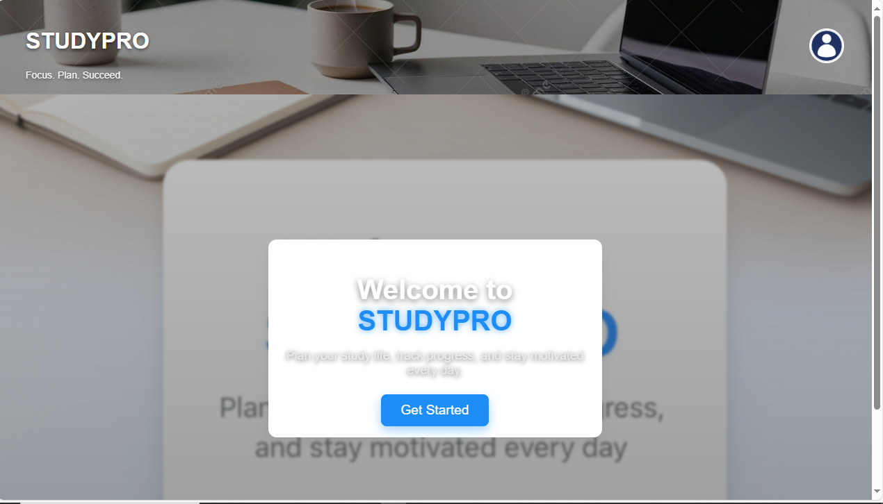
After clicking “Get Started”, new users are taken to the registration page, where they can create an account by providing their full name, student email, password, and notification preferences. Upon successful registration, a confirmation message is displayed, ensuring the user that their account has been created. A verification email is then automatically sent to finalize the setup (Nielsen, J. 2020).
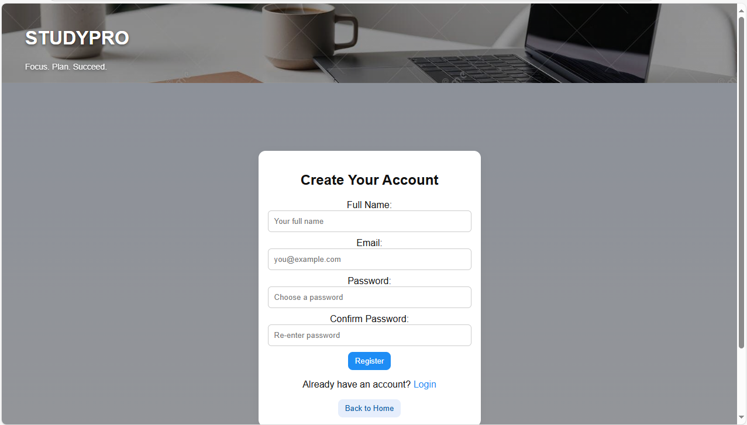
Returning users can log in through the login page using their credentials. To enhance accessibility and efficiency, the login process uses a simple form with clear labels and a “Back” button for easy navigation (Nielsen, J. 2020).
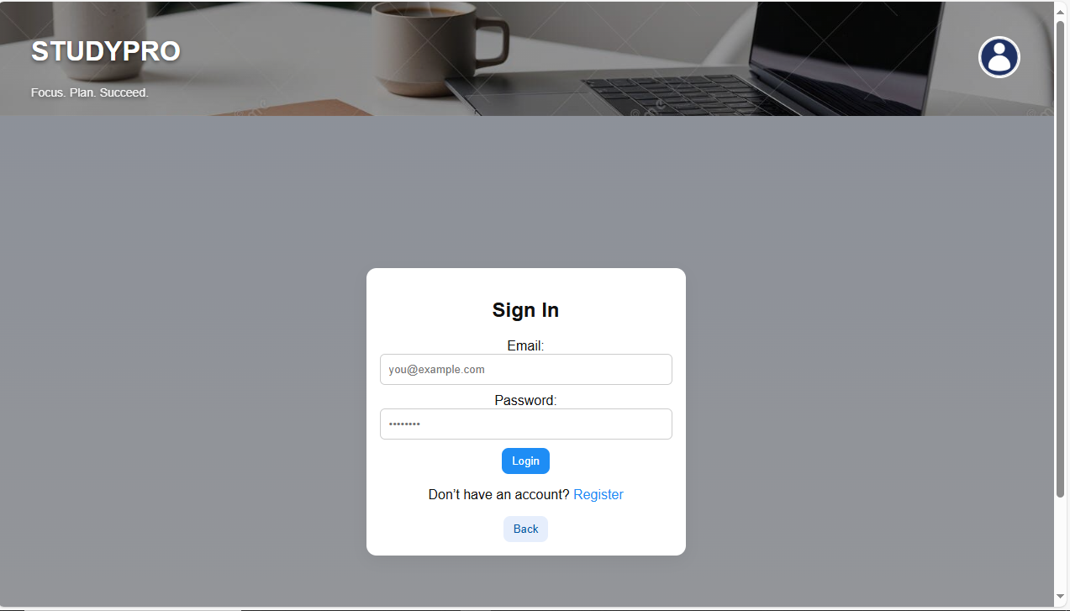
Once logged in, users are directed to the dashboard, the main hub of StudyPro. Here, students can view active tasks, upcoming deadlines, progress charts, motivational quotes, and a Pomodoro timer to manage study intervals effectively. The dashboard provides a user-friendly interface, allowing students to add tasks with priorities, receive personalized study block recommendations, and track progress visually (Nielsen, J. 2020).
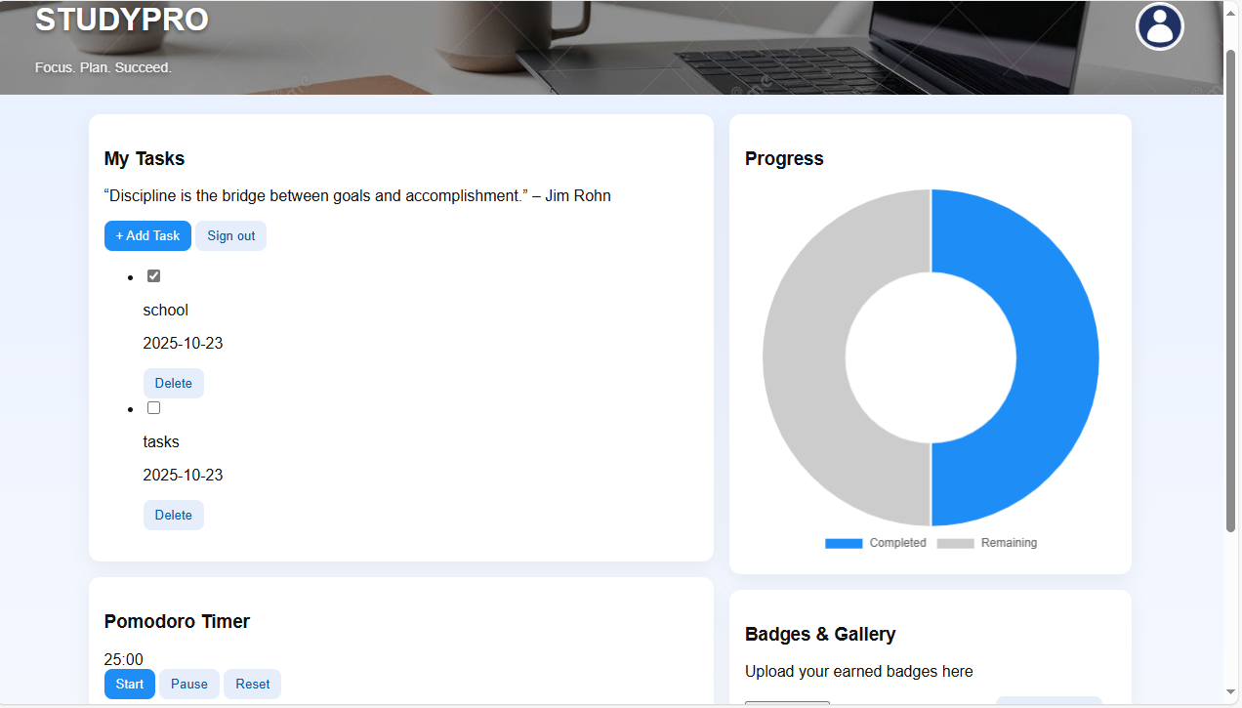
New tasks can be added through the “Add Task” button, opening a modal form with fields for the title, due date, priority level, and optional notes or images. Once added, tasks appear immediately in the task list, and completed tasks can be marked as done or removed easily.
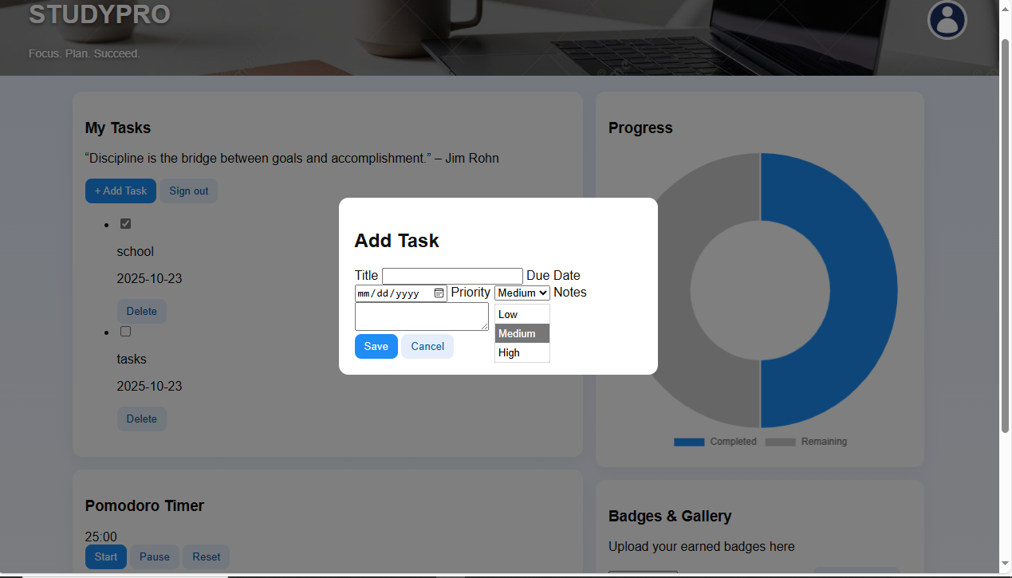
StudyPro also incorporates social and collaborative features. For group assignments, students can create shared planners, invite classmates, and set collective deadlines. Each member receives notifications and updates, promoting accountability and collaboration. A basic forum section allows students to share study tips and maintain peer support (Nielsen, J. 2020).
The platform integrates gamification and motivational tools through the Badges and Gallery section, where users can upload screenshots and view earned badges. Positive feedback messages, streak counters, and inspirational quotes encourage consistent study habits and celebrate academic achievements.
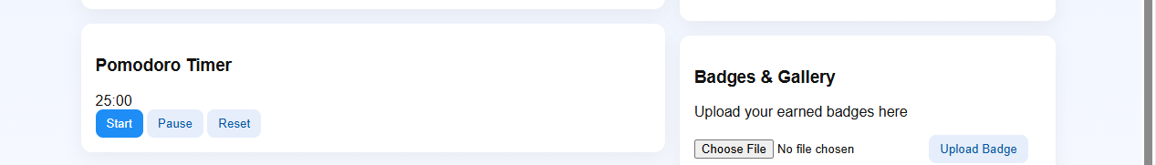

Finally, users can sign out securely, with all data automatically preserved for future sessions. StudyPro ensures that every interaction, from registration to task completion, is meaningful, efficient, and rewarding, helping students stay organized, reduce procrastination, and improve academic productivity (Nielsen, J. 2020).
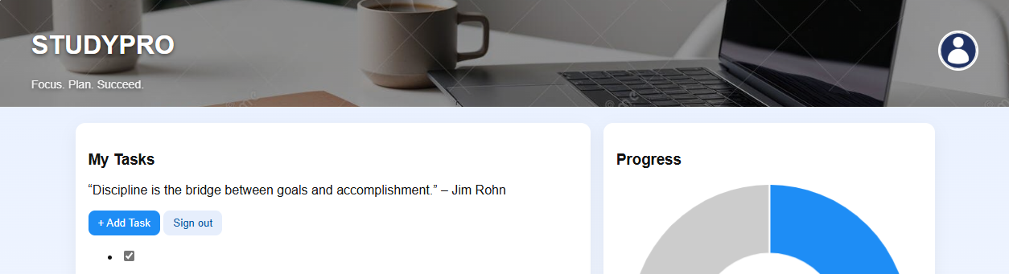

2.3 Design Principles
The prototype follows core design principles of consistency, contrast, alignment, and proximity. All pages use the same header, button styles, and card structure, which helps students recognize patterns and build familiarity.
Contrast is achieved using the accent blue for interactive elements, ensuring users can easily identify clickable buttons and links. Alignment ensures all text and cards follow a grid, maintaining a professional and readable layout. Proximity is applied by grouping related elements for example, task input fields and buttons appear together in the modal form, reducing cognitive effort (Nielsen, J. 2020).
Repetition of visual elements such as button shapes and card corners strengthens brand identity, while white space provides balance and readability. These combined design principles enhance both usability and aesthetic appeal.
Consistent dashboard layout showing structured alignment, repeated visual elements, and clear visual hierarchy” (Nielsen, J. 2020).

2.4 Interaction Types
The StudyPro prototype integrates several interaction types to ensure engagement and fluid navigation (Nielsen, J. 2020):
- Instructional Interaction: Used in registration, login, and task creation forms where users provide input.
- Conversational Interaction: Implemented in pop-up alerts, confirmation modals, and motivational messages that simulate dialogue with the user.
- Manipulation Interaction: Present in the badge and gallery upload feature, where users interact with media elements.
- Exploratory Interaction: Found in the dashboard and charts, where users can view and interpret their performance visually (McKay, E. 2021).
These interactions create a dynamic environment that feels interactive and alive, rather than static or mechanical. Every click and modal provides instant feedback, reinforcing engagement and confidence (McKay, E. 2021).
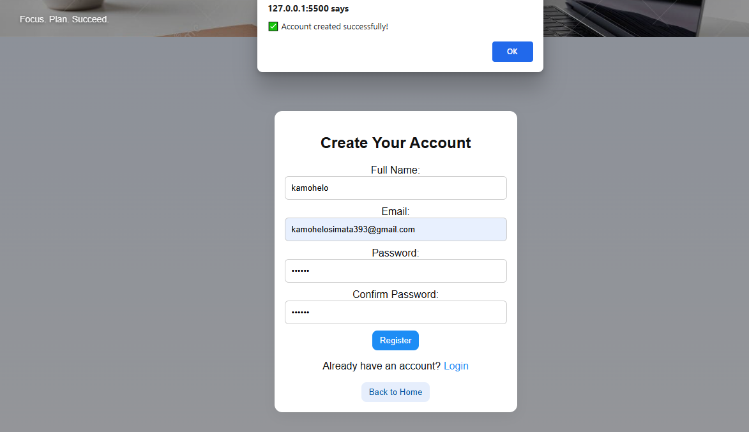
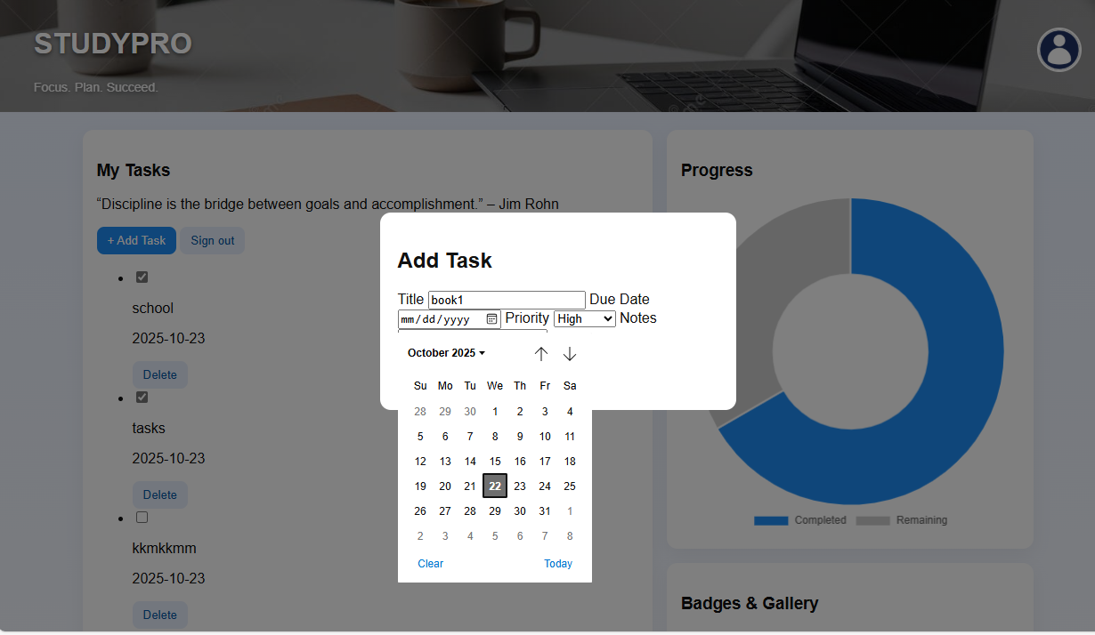

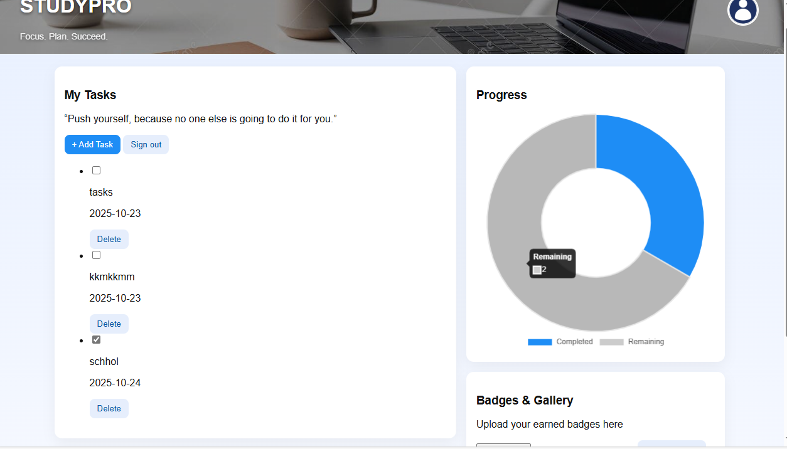

2.5 Social Interactions
While the current prototype is designed for individual users, its structure allows for future social features such as collaborative planners or shared progress tracking. I planned the system architecture so that users could eventually share badges or compare progress in study groups.
Currently, the Badges & Gallery section serves as the foundation for these social interactions. It lets students display their achievements, upload screenshots, and take pride in their learning journey a small but important social motivator (McKay, E. 2021).
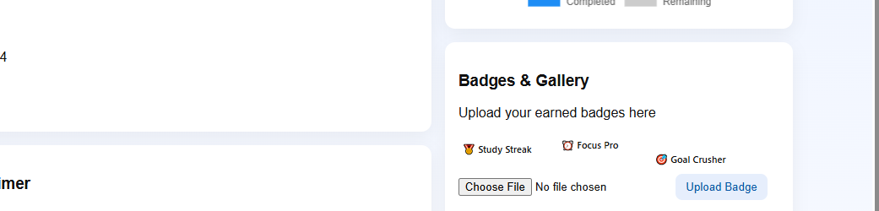

2.6 Emotional Interaction
Emotional interaction is central to StudyPro’s success. The platform uses positive reinforcement through motivational text (“Well done!”) and warm color tones (soft blues, whites, and subtle gradients) that create a sense of calm (McKay, E. 2021).
The landing page instantly builds emotional connection with the slogan “Focus. Plan. Succeed.” and a visually appealing blurred-card design that feels uplifting. Celebratory feedback (like earning a badge or completing a task) boosts confidence and keeps the user emotionally invested.
By combining soothing visuals, encouragement, and clear structure, the site turns study management from a chore into a rewarding experience (McKay, E. 2021).

2.7 Accessibility and Guidelines (WCAG 2.1)
To ensure inclusivity, the prototype was developed using WCAG 2.1 accessibility principles. All forms have labeled inputs and clear placeholder text to support screen readers. The site supports keyboard navigation users can move between fields and buttons using only the keyboard.
Color contrast (blue buttons on white backgrounds) meets readability standards. Images include alt text for assistive technology, and scalable font sizes enhance readability on different screens.
Accessibility ensures every student, regardless of ability, can use StudyPro comfortably. This commitment to inclusivity strengthens the ethical and human-centered design foundation of the project.

4. Conclusion
The improved StudyPro prototype demonstrates a balanced integration of usability, emotional design, and accessibility. Each feature from the Pomodoro timer to motivational feedback serves the goal of empowering students to manage time effectively while staying emotionally encouraged (Rogers, Y.,et al 2019).
Through thoughtful interaction design, consistent visuals, and inclusive implementation, StudyPro not only organizes study life but also makes the experience enjoyable, motivating, and meaningful. This combination of structure and empathy ensures students remain productive and positive throughout their learning journey (Rogers, Y.,et al 2019).

References
- Nielsen, J. 2020. 10 Usability Heuristics for User Interface Design. Nielsen Norman Group. Available at: https://www.nngroup.com/articles/ten-usability-heuristics/ [Accessed 15 September 2025].
- ISO 2019. ISO 9241-210:2019 Ergonomics of human-system interaction — Part 210: Human-centred design for interactive systems. International Organization for Standardization. Available at: https://www.iso.org/standard/77520.html [Accessed 15 September 2025].
- W3C 2021. Web Content Accessibility Guidelines (WCAG) 2.1. World Wide Web Consortium (W3C). Available at: https://www.w3.org/TR/WCAG21/ [Accessed 15
September 2025].
- Rogers, Y., Sharp, H. and Preece, J. 2019. Interaction Design: Beyond Human-Computer Interaction. 5th ed. Wiley.
- McKay, E. 2021. Designing with empathy: Emotional interactions in web applications. International Journal of Human-Computer Studies, 150, p.102608. RUBRIC

